Gilbert Gilkes & Gordon Ltd

Candidate Brief

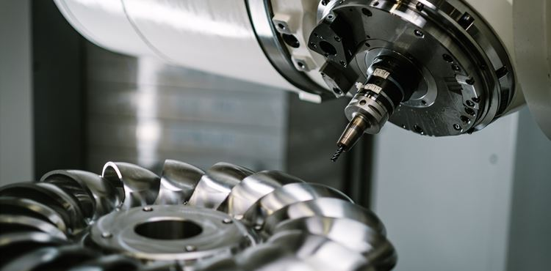

|  |  |  |
| --- | --- | --- |
| **Background**  Gilkes provides innovative, single-source solutions for the Small Hydropower and High Horsepower Diesel Engine markets.  By working closely with our customers, we ensure excellence in product design, total cost of ownership, and operational performance. Our hydropower turbines and engine cooling pumps are engineered to meet the most demanding technical specifications and environments.  With a legacy spanning over 170 years, a Royal Warrant, and a global presence in more than 85 countries, we combine agility and responsiveness with the technical expertise of a world-leading brand.  Headquartered in Kendal, in the heart of the English Lake District, Gilkes is an independently owned company with approximately 175 employees worldwide. Our operations include manufacturing facilities in Kendal and Houston, 3 Service Centres in Scotland and a sales office in Tokyo. |  | **Our Purpose**  Rooted in a 170-year heritage as a family-owned business, our values-driven approach prioritises ethical business relationships and a commitment to environmental sustainability.  We are dedicated to delivering long-term, responsible success by ensuring our products contribute meaningfully to the transition toward a low-carbon economy.  **People & Culture**  Our people are at the core of everything we do - they are the driving force behind our success. Their passion, creativity, and dedication enable Gilkes to thrive and grow.  We are committed to investing in our employees and fostering a positive, inclusive company culture.  Our 4 key values are:   * Teamwork * Integrity * Excellence * Commitment |
| **Current Position & Context**  Gilkes is rapidly evolving to stay ahead in an ever-changing economic landscape, ensuring our continued relevance in our chosen markets.  Our pumps business continues to expand, particularly in the power generation sector, where the rising demand for standby power for large data centres is driving growth. |  | In the UK, the hydro aftermarket presents significant growth opportunities for Gilkes. We are strategically aligning our Service, Modernisation, and Control Systems teams to maximise these prospects.  The small hydropower market is shifting toward energy recovery, and our existing product portfolio positions us well to capitalise on this trend. |

**Our Business Model & Strategy**

|  |  |  |  |
| --- | --- | --- | --- |
| **What we do…**  We leverage opportunities through our expertise, dedication & agility | **Client Acquisition & Development**  Our customer-facing teams foster open & transparent communication with clients  We build and sustain customer relationships with integrity and ethical practices | **Project**  **Delivery**  Our goal is to achieve 100% on-time, in-full project delivery  A structured process ensures optimal resource allocation and efficiency | **Product Life Cycle**  **Management**  We actively manage & support products throughout their lifecycle, from initial production through to spares, service & refurbishment |

|  |  |  |  |
| --- | --- | --- | --- |
| **How we do it…**  We continuously enhance our products and services to drive our customers' success | **Customer**  **Service**  We go above and beyond for our customers whenever needed, without hesitation  We stand behind our products and honour our commitments | **Focus on**  **Productivity**  Business excellence is at the core of our organisation  We continuously evaluate our end-to-end processes to eliminate inefficiencies and maximise value | **Expanded**  **Offerings**  Expanding our product range to better serve our customers' needs  Delivering solutions with distinct value propositions |

|  |  |  |  |
| --- | --- | --- | --- |
| **Our competitive advantage…**  We are dedicated to fostering a high-performance workplace where our employees can thrive | **Our**  **People**  We believe our people are the key to our competitive edge  We are committed to fostering a culture of empowerment and success | **Our**  **Processes**  High productivity gives us a competitive edge  Our processes are strategically designed & managed to maximise stakeholder value | **Our**  **Agility**  We utilise mechanisms to detect changes in the external environment and convert them into potential opportunities |

**Some of Our Customers**

|  |
| --- |
| **Hydro** |
| **Pumps** |

**The Appointment**

|  |  |
| --- | --- |
| **Role Title** | CNC Machinist |
| **Reporting to** | Shift Leader |
| **Company** | Gilbert Gilkes & Gordon Ltd |
| **Website** | [www.gilkes.com](http://www.gilkes.com) |
| **Based** | Kendal |
| **Remuneration** | £24,625 to £31,465 plus Generous Shift Rate of 44.4% (3-shift) |
| **Other Benefits** | Attractive Pension Scheme (Employer 10% contribution & employee 4%), Cycle to Work Scheme, Life Insurance (3x annual salary), 25 days holiday plus bank holidays (and the option to buy more!) |

|  |  |  |
| --- | --- | --- |
| **Overview**  Gilkes is looking to appoint a CNC Machinist to produce parts on 3 and 4 axis machines. Reporting into the Shift Leader, you will work closely with the wider operations team.  In this role you will be responsible for producing machined parts by setting up and operating a computer numerical control (CNC) machine whilst maintaining quality and safety standards.  Training will be provided on the job for any candidate wanting to embark on a new career in CNC Machining. |  | **Expectations**   * Pro-actively contribute to the smooth running of the operations team * Represent Gilkes positively & appropriately * Uphold the company’s code of conduct * Do not engage in any activity which could be detrimental to Gilkes |
| **Responsibilities**   * Adhere to safety procedures and regulations * Mill and turn set up * Verifying settings by measuring and adhering to engineering drawing standards * Maintain specifications by adhering to quality assurance procedures and processes |  | **Experience/personal skills**   * Minimum GCSE grades A – C in English and Mathematics or equivalent qualification * Ability to deliver high quality work and to tight deadlines   ***This role will support a shift pattern of 6:00am to 2:00pm, 2:00pm to 10:00pm and 10:00pm to 6:00am. This pattern attracts a generous shift rate allowance of 44.4%*** |
| **Person Specification**   * Good attention to detail * Strong communication and organisational skills, including written and verbal * Demonstrate resilience and flexibility; adapts well to new circumstances * High energy and commitment |  |  |

**To apply, please forward your CV to** [**recruitment@gilkes.com**](mailto:recruitment@gilkes.com)**. We reserve the right to close this vacancy early if we receive sufficient applications for the role.**