How to Measure Head

Head is often measured in meters and represents the vertical distance between where the water is extracted from and the location of the turbine.

The Head measurement is important as it not only contributes to the power output of the system but also determines the type of turbine that best suits your hydro site.

Determining the Head at your site is a challenging prospect. The intake is often quite a distance from the proposed location of the turbine and as it is the vertical distance we require is seems impossible at first.

The key is to measure the Head in stages, record each value, and calculate the sum of these values at the end.

The diagram below offers an illustration of how this can be done.

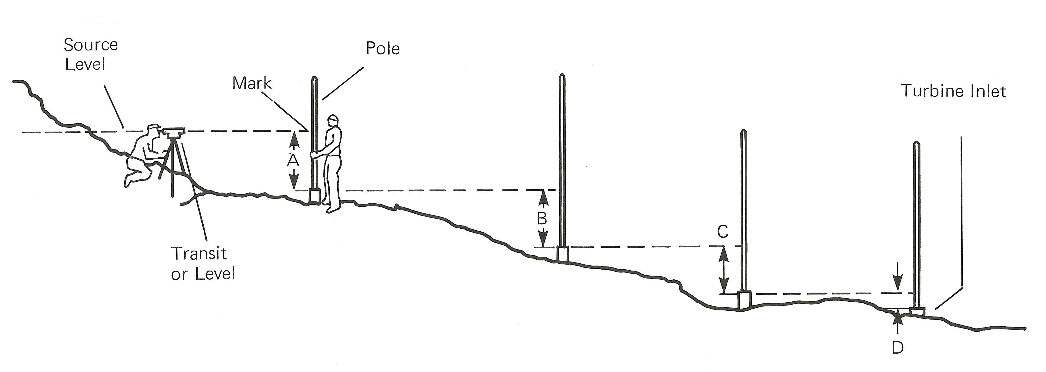

You will need;

Two posts which will act as the vertical poles in the diagram
A Spirit Level
A long and straight plank to determine the horizontal level
Note Pad and Pencil
Tape Measure

Procedure

It is possible to determine the Head value alone but much easier with two people. The instructions below assume you have an assistant.

- Starting at the proposed location of the turbine hold the first pole vertical and retain the spirit level and tape measure.
- Your assistant should proceed up the hill and position the second pole in a suitable location up the hill.
- Between you, place the plank from the foot of the higher vertical pole so it touches the lower vertical pole. The horizontal plank must be vertical so use your spirit level to be sure of this.
- Measure the vertical distance between the base of the plank and the floor level using your tape rule and record this measurement.
- Keeping the higher vertical pole in the same location move the lower pole higher up the hill and repeat the measuring process until you reach the proposed water intake.
- Accumulate your recordings. The sum of these numbers gives you the Head of you site.

