How to Measure Flow

Flow is volume of water passing through the turbine and is often measured in m^3/second or litres/second.

Depending on the nature of your site the flow may vary throughout the year.
The flow is streams and rivers fluctuate with the seasons so taking seasonal measurements is advisable for these type of projects. Alternatively historical flow data for the river may be available from the water authority which would ensure the best selection of turbine can be chosen for your site. Local wildlife may depend on the water in the river for their survival so consulting your local environment agency is advisable prior to concluding if the project is feasible.

Small Streams

If the flow in your stream is quite low then this method works perfectly well. For more substantial flows other methods, which are listed later in this document, should be used.

You will need;

Suitable materials to build a temporary dam (rocks to act as boulders works well)
A length of pipe
A container with a known volume
Stopwatch

Procedure

- Construct your temporary dam around your length of pipe so all the flow in the stream is channelled through the pipe.
- Position your container so all the flow will enter it and, using your stopwatch, time the length of time it takes to fill your container.
- Repeat instruction 2 a number of times, recording the time on each test.
- Divide the sum of your times by the number of tests you performed.
- Divide the container size/volume by the average time taken.

Example

Using a 20 litre container with an average fill time of 4 seconds

20 divided by 4 = 5

Therefore the average flow in your stream would be 5 litres/second

Medium/Large Streams

For streams with a healthy or abundant flow we would recommend measuring the speed of a float to travel over a known distance and volume of water.

You will need;

A consistent section of the stream of approximately 3 meters in length (the more consistent the section, in terms of width and depth, then the more accurate the results)
A solid material, marked at 1ft intervals, to span the width of the stream
A large Rule
Note Pad and Pencil
A weighted Float

Note
It is important to record the units you are measuring in. Using meters and seconds throughout will results in your average flow being in m^3/second units.

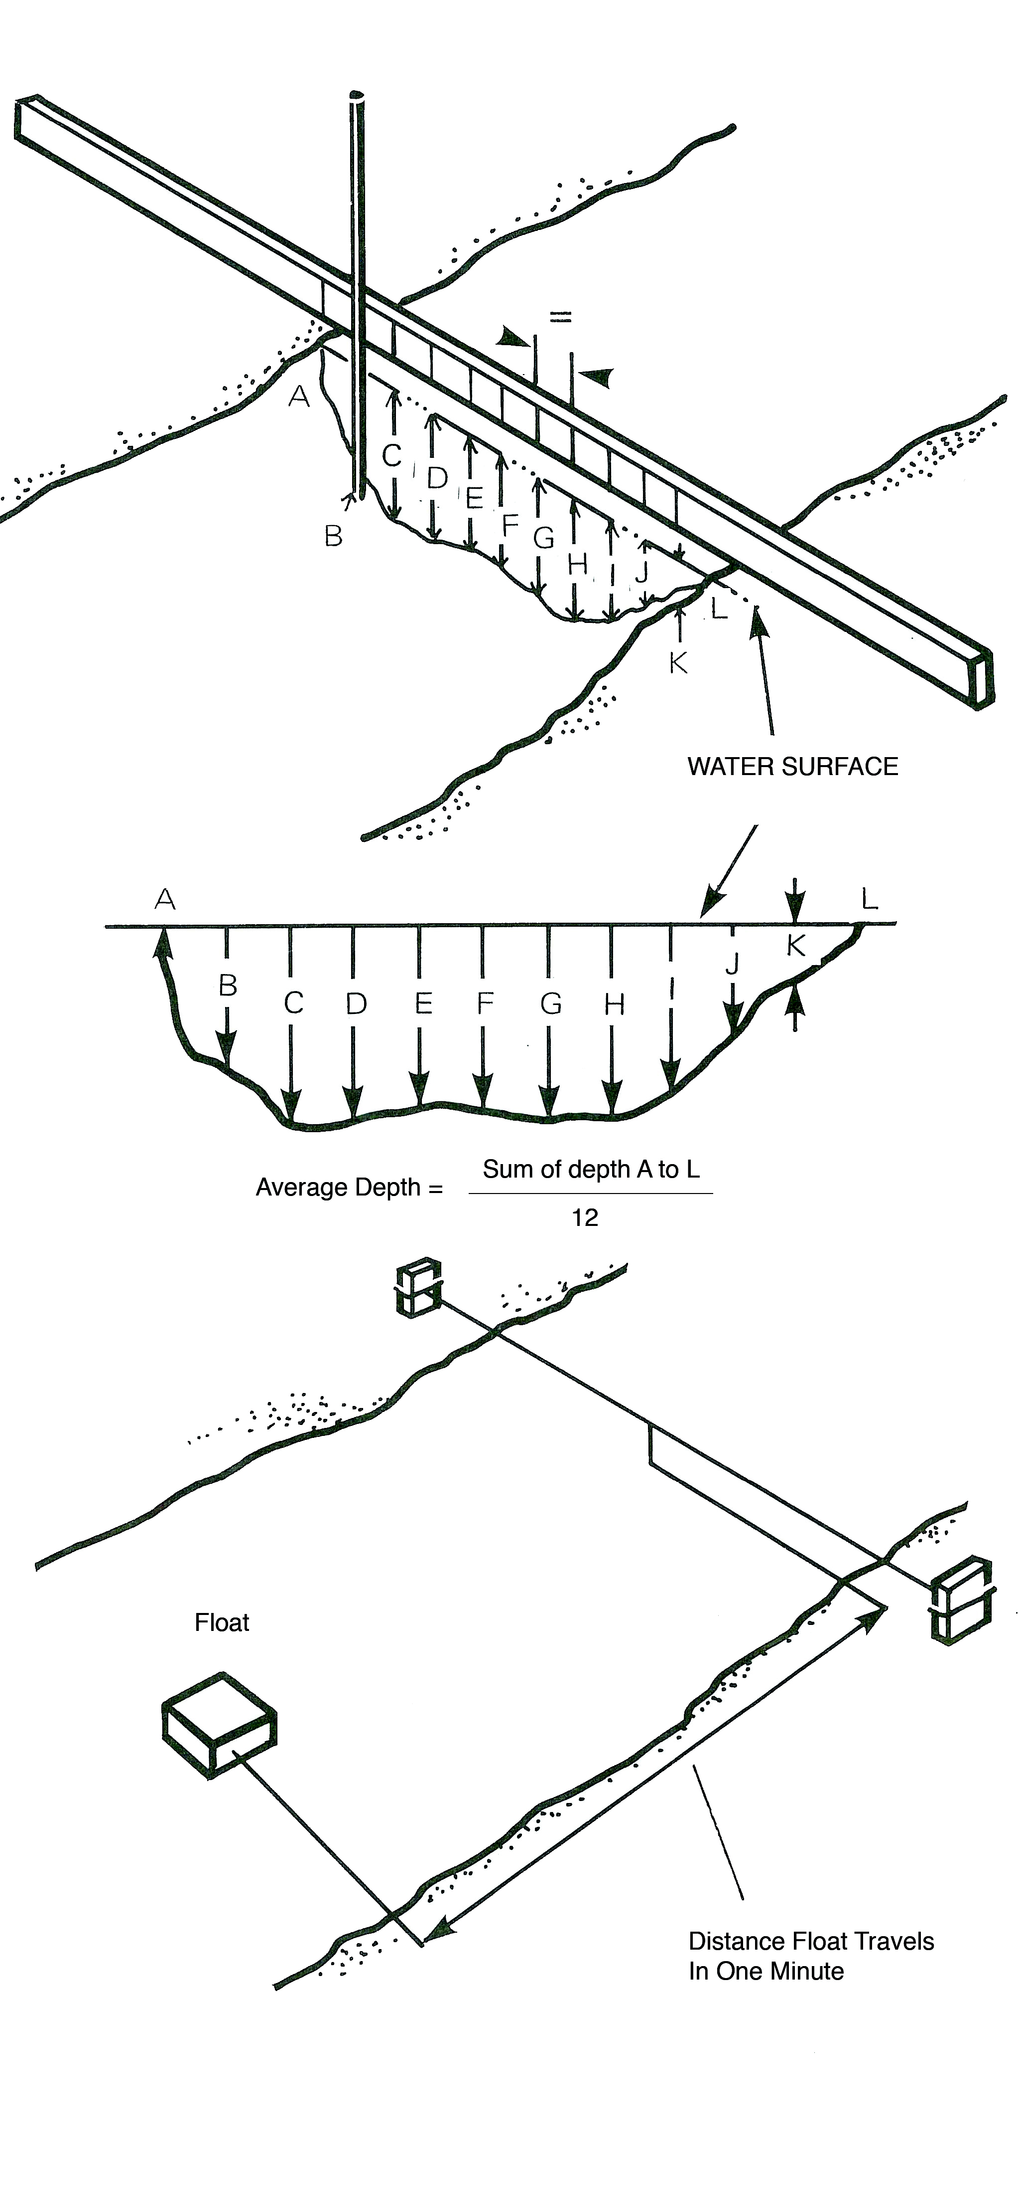
Procedure

- In the centre of your selected section of stream, span your marked solid material securely across the width of your stream. i.e. there will be 1.5 meters of consistent river either side of your board.
- Using your rule measure the depth of the stream at each marked interval on your board and record this information.
- Calculate the average depth of the river by adding all your depth recordings and dividing this sum by the number of recordings you made.
- You have now calculated the Average Depth of the stream.
- Measure the width of the stream and multiply this figure by the Average depth of the stream. This gives you the Cross-Section Area of the stream.
- Place your weighted float in the river well upstream of you 10ft section and, using a stopwatch, record the time the weighted float takes to cover your selected section. You will start your stopwatch when the weighted float enters your section and stop it when it ends your section.
- Do this a number of times and record the time taken on each occasion.
- Calculate the Average Time of the weighted float by adding your time recordings together and dividing by the number of tests you performed.
- We can now calculate the Speed by dividing the distance (3 meters) by the Average Time from instruction 8.
- Then you can calculate the Average Flow (Surface) by multiplying the Average Speed by the Cross Section Area from instruction 5.
- As the flow on the surface of a stream always exceeds the flow on the bed of a stream multiply your Average Flow (Surface) by 0.82 (82%) to obtain the overall Average Flow.

Formulas

Average Depth = Sum of depth recordings / Number of recordings
Cross-Section Area = Average depth X Width of stream
Average Time = Sum of time recordings / Number of recordings
Average Speed = Average Time X Distance travelled in that time
Average Flow (Surface) = Average Speed x Cross- Section Area
Average Flow = Average Flow (Surface) X 0.82

