Gilkes Guide to Small Hydro

This guide is designed to assist those individuals considering the development of a small scale hydro project. We class ‘small scale hydro’ as any project which generates less than 100kW. To put this into perspective the average power consumption for a UK home is approximately 2kW, so in hydro terms ‘small’ amounts of generated power can still be quite substantial quantities of electricity.

How Hydro Power Works

Hydro power is generated by harnessing the potential energy of a head of water and turning it into electrical power.

The potential energy is a product of the Head and Flow of your hydro site and the more Head and Flow you have the more power you can potentially generate.

Head
Head is often measured in meters and represents the vertical distance between where the water is extracted from and the location of the turbine.

Flow
Flow is volume of water passing through the turbine and is often measured in m^3/second or litres/second.

From the Head and Flow we can calculate how much power is contained within the water as it enters the turbine. It is at this stage of the process where the potential energy from your hydro site is transformed into mechanical energy and it’s the turbine Runner which performs this function. Depending on the most suitable type of turbine for your site the water will either pass through (Reaction Turbine) or be forced against (Impulse Turbine) the turbine Runner. This interaction forces the Runner to rotate which turns the turbine shaft. The turbine shaft is coupled, either by a belt system or directly, to the generator shaft which relays the mechanical energy of the shaft into the generator. The generator then converts this mechanical power into electrical energy using electromagnets.

So, to calculate the potential power at your hydro site we need the two pieces of information listed above; Head and Flow. To assist you in obtaining this information we have produced How to Measure Head and How to Measure Flow which offers some guidance on some simple methods you can use to obtain these values.

Medium/Large Streams

For streams with a healthy or abundant flow we would recommend measuring the speed of a float to travel over a known distance and volume of water.

You will need;

A consistent section of the stream of approximately 3 meters in length (the more consistent the section, in terms of width and depth, then the more accurate the results)
A solid material, marked at 1ft intervals, to span the width of the stream
A large Rule
Note Pad and Pencil
A weighted Float

Note
It is important to record the units you are measuring in. Using meters and seconds throughout will results in your average flow being in m^3/second units.

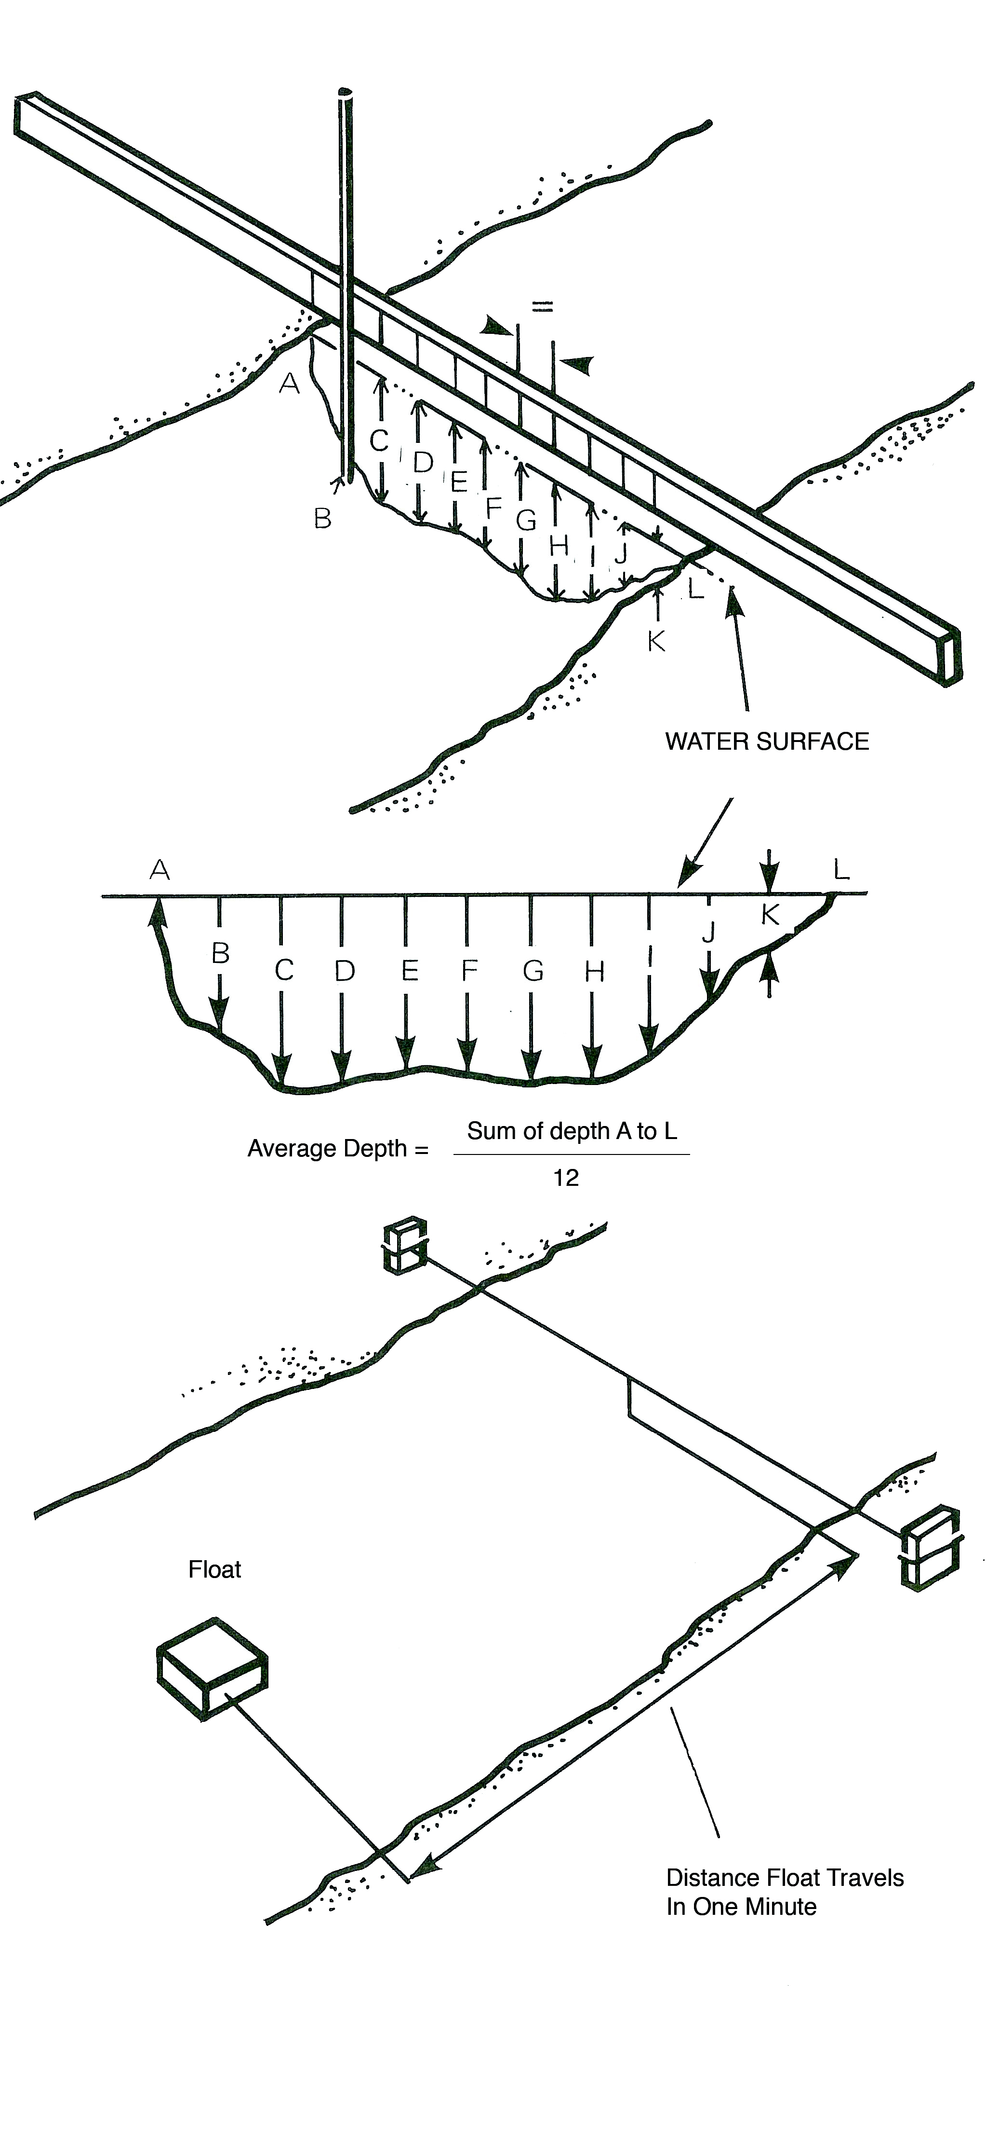
Procedure

- In the centre of your selected section of stream, span your marked solid material securely across the width of your stream. i.e. there will be 1.5 meters of consistent river either side of your board.
- Using your rule measure the depth of the stream at each marked interval on your board and record this information.
- Calculate the average depth of the river by adding all your depth recordings and dividing this sum by the number of recordings you made.
- You have now calculated the Average Depth of the stream.
- Measure the width of the stream and multiply this figure by the Average depth of the stream. This gives you the Cross-Section Area of the stream.
- Place your weighted float in the river well upstream of you 10ft section and, using a stopwatch, record the time the weighted float takes to cover your selected section. You will start your stopwatch when the weighted float enters your section and stop it when it ends your section.
- Do this a number of times and record the time taken on each occasion.
- Calculate the Average Time of the weighted float by adding your time recordings together and dividing by the number of tests you performed.
- We can now calculate the Speed by dividing the distance (3 meters) by the Average Time from instruction 8.
- Then you can calculate the Average Flow (Surface) by multiplying the Average Speed by the Cross Section Area from instruction 5.
- As the flow on the surface of a stream always exceeds the flow on the bed of a stream multiply your Average Flow (Surface) by 0.82 (82%) to obtain the overall Average Flow.

Formulas

Average Depth = Sum of depth recordings / Number of recordings
Cross-Section Area = Average depth X Width of stream
Average Time = Sum of time recordings / Number of recordings
Average Speed = Average Time X Distance travelled in that time
Average Flow (Surface) = Average Speed x Cross- Section Area
Average Flow = Average Flow (Surface) X 0.82

